ECOLOGICAL STUDIES ON LENTIL, RHIZOBIA;
COMPETITION AND PERSISTENCE
IN SOME TROPICAL SOILS

A THESIS SUBMITTED TO THE GRADUATE DIVISION OF THE
UNIVERSITY OF HAWAII IN PARTIAL FULFILLMENT
OF THE REQUIREMENTS FOR THE DEGREE OF

MASTER OF SCIENCE

IN MICROBIOLOGY

DECEMBER, 1979

By

Sheila N. May

Thesis Committee:
B. Ben Bohlool, Chairman
L. R. Berger
A. S. Whitney
ACKNOWLEDGEMENTS

I am extremely grateful to Dr. B. Ben Bohlool, Department of Microbiology, for his guidance, patience, and enthusiasm throughout all phases of this research,
I would like to thank Dr. Jim Silva, Department of Agronomy and Soils, for his help with the statistical analysis of data and Dr. Robert Fox, Department of Agronomy and Soils, for the use of his experimental phosphorus plots.
In addition, I would like to thank the NifTAL Project, College of Tropical Agriculture, for the research assistantship and financial support which made this research possible.
ABSTRACT

Thirty-one strains of Rhizobium leguminosarum were screened for their ability to fix nitrogen (effectiveness) on lentils (Lens esculenta). Fluorescent antibodies prepared against four of the most effective strains (NZP 5400, Hawaii 5-0, Nitragin 128A12, and Nitragin 128C53) and one other effective strain, Nitragin 175P1, were strain specific. NZP 5400, Hawaii 5-0, and Nitragin 128A12 were selected for competition studies. Rhizobia in lentil nodules were identified by immunofluorescence. In two separate growth chamber studies all possible combinations of the three strains were used to inoculate lentil seedlings grown in sterile vermiculite. In the first study which involved a commercial lentil cultivar, the following results were obtained: Hawaii 5-0 and NZP 5400 were equally competitive against one another and one-third of the nodules contained both strains; Nitragin 128A12 was a poor competitor against either of the other two strains and the incidence of double infection was much lower. The second growth chamber study involved three lentil cultivars (Benewah, Chilean, and Tekoa). Results of two strain competition were: NZP 5400 was superior to Nitragin 128A12 on all three cultivars and only 6% of the nodules were doublyinfected; NZP 5400 was slightly superior to Hawaii 5-0 on the Chilean cultivar, but the two were equally competitive on the other two cultivars and one-third of the nodules were doubly-infected; Nitragin 128Al2 dominated Hawaii 5-0 on both Benewah and Tekoa and the two were equally competitive on Chilean with one-third of the nodules being doubly-infected. In three strain competition NZP 5400 was superior to the other two strains on Tekoa and Chilean but all three strains were equally competitive on Benewah.
The two most competitive strains from the first study, NZP 5400 and Hawaii 5-0, were further tested in the field in a Hawaiian inceptisol (Ustic Humitropept, pH 6.1). Commercial lentil seeds were pelleted with equal numbers of both strains. The two strains were equally competitive against one another and both were dominant against the native ineffective strains of lentil rhizobia which were present in low numbers. One-third of the nodules contained both of the introduced strains. One year later, uninoculated lentil seeds were planted in these same field plots to assess the persistence of these two strains. Both strains persisted over this period, but the Hawaiian isolate, Hawaii 5-0, was present in a higher proportion (51%) of the nodules. Only 24% of the nodules contained both strains.
The competitiveness of all three strains was tested in another field experiment in a Hawaiian oxisol (Tropeptic Eutrustox, pH 5.8). Commercial lentil seeds were pelleted with equal numbers of all three strains and competition was assessed at low, medium, and high levels of phosphorus. Early (10 days) and late (8 weeks) sampling of nodules yielded the following results: Hawaii 5-0 was superior to the other two strains at the low phosphorus level; Hawaii 5-0 and Nitragin 128A12 were equally competitive at the medium phosphorus level; all three strains were approximately equal in competitiveness at the high phosphorus level. The incidence of double-infection varied from 0% to 26% depending on the phosphorus level and the sampling time.
TABLE OF CONTENTS
Page
ACKNOWLEDGEMENTS.................................... 2
ABSTRACT............................................ 3
LIST OF TABLES...................................... 6
LIST OF FIGURES..................................... 7
CHAPTER 1: INTRODUCTION............................. 8
CHAPTER 2: LITERATURE REVIEW........................ 10
CHAPTER 3: MATERIALS AND METHODS.................... 16
CHAPTER 4: RESULTS.................................. 28
CHAPTER 5: DISCUSSION............................... 45
BIBLIOGRAPHY........................................ 52

LIST OF TABLES
Table Page

1 Sources of cultures......................... 17

2 Acetylene reduction screening of
Rhizobium leguminosarum strains on
lentils (Lens esculenta).................... 29

3 Specificity test of Rhizobium legum-
inosarum fluorescent antibodies............. 30

4 Percentage of nodules formed by
inoculated strains of Rhizobium legum-
inosarum (Commercial variety) .............. 31

5 Percentage of nodules formed on three
lentil cultivars by inoculum strains of
Rhizobium leguminosarum..................... 36

6 Competition between introduced and
indigenous strains of Rhizobium legum-
inosarum on field-grown lentils (Commer-
cial variety)............................... 38

7 Persistence of Rhizobium leguminosarum
strains in an Hawaiian inceptisol........... 40

8 Percentage of nodules formed by intro-
duced strains of Rhizobium leguminosarum
on field-grown lentils over three sampling
periods at three phosphorus levels.......... 41

9 Summary of three strain competition:
comparing Growth Chamber Competition
Experiment I vs. Field Experiment III....... 42

10 Rhizobium leguminosarum strains recovered
from soil cores at the termination of
Field Experiment I.......................... 44
LIST OF FIGURES
Figure Page
1 Lentil nodule containing one strain
of Rhizobium leguminosarum................... 35

2 Lentil nodule containing two sero-
logically distinct strains of
Rhizobium leguminosarum...................... 35
CHAPTER 1
INTRODUCTION

Bacteria of the genus Rhizobium comprise a large group of free-living soil bacteria. These bacteria, diverse in such characteristics as colony morphology, biochemistry, growth and serology, have in common the ability to form a specific symbiotic association with leguminous plants. As a result of this association the rhizobia fix atmospheric nitrogen into a combined form which the plant can use. However, Rhizobium strains with the ability to infect a particular legume vary in effectiveness (nitrogen-fixing ability) and many strains are completely ineffective (non-nitrogen-fixing). Thus, one of the most important objectives in legume inoculation research is the selection of the most effective strains of rhizobia for a particular host. In addition, inoculant strains must have the ability to compete successfully for nodule sites against the indigenous soil microflora which may include ineffective strains of rhizobia. There have been many reports of differential competition between effective and ineffective strains (Nicol and Thornton, 1941; Robinson, 1969; Russell and Jones, 1975; Franco and Vincent, 1976) as well as between effective strains (Caldwell, 1969; Marques Pinto et al. 1974).
Differential competition has been attributed to relative growth rates of competing strains in the rhizosphere (Nicol and Thornton, 1941), preferential selection of a strain by the host (Vincent and Waters, 1953), differential ability to tolerate a particular pH (Russell and Jones, 1975a), climate and soil factors (Read, 1953), and antagonism between competing strains (Schwinghamer, 1971).
The ability of elite Rhizobium strains to persist in the soil over prolonged periods of time has also been shown to be desirable, particularly with respect to clover species and other pasture legumes (Brockwell and Dudman, 1968; Dudman and Brockwell, 1968; Bergersen, 1970; Date, 1970; Chatel et al. 1973; Gibson et al. 1976). This ability may also be important to ensure prompt effective nodulation of grain legumes when inoculation every season may not be practical or practiced.
The purpose of this research was:
(1) to determine those strains/isolates of Rhizobium leguminosarum which were the most effective on lentils (Lens esculenta) by screening all available cultures;
(2) to assess the competitiveness of three of the most effective strains under both controlled and field conditions;
(3) to assess the persistence of two of the most competitive strains under field conditions.
In order to study both competition and persistence the proper methodology is required to identify inoculant strains. In this study immunofluorescence was used for Rhizobium strain identification.
CHAPTER 2
LITERATURE REVIEW

Competition between Rhizobium Strains

The early experiments of Dunham and Baldwin (1931) revealed that when pairs of effective and ineffective Rhizobium strains were applied simultaneously to either alfalfa, clover, peas, or soybeans there was variability in which strain would be successful in nodulation. Thus, the majority of the nodules on the host were not necessarily formed by the effective strain. In addition, ineffective and effective nodules could be present on the same plant. If both types of nodules were present, the growth and nitrogen content of the plant was intermediate between that of plants which had only ineffective or effective nodules, This has also been observed with both crimson clover (Burton and Allen, 1949) and white clover (Jones and Russell, 1972). Burton and Allen (1949) also showed that if plants were inoculated with mixtures of only effective strains, the growth and nitrogen content of the plants were slightly superior to that of plants which received only a single effective strain as inoculum. This has also been confirmed by other investigators (Dorosinskii and Makarova, 1976; Bordeleau and Antoun, 1977).
Dunham and Baldwin (1931) proposed that Rhizobium strains may vary in their ability to infect the host with this ability being independent of effectiveness.
Nicol and Thornton (1941) showed that pairs of ineffective and effective Rhizobium strains compete in the rhizosphere of the host plant. In their experiments with clover and pea, the strain with the higher initial growth rate formed the majority of the nodules. They concluded that effectiveness and competitiveness are independent characteristics, and when competition between strains occurs in the rhizosphere, relative infectivity can be masked.
Harris (1953) related dominance in competition to not only the ability of a strain to proliferate in the host rhizosphere but also to a property he labelled "incursion." Harris described this as the ability of a strain to migrate from the initial site of inoculation and establish in the root zone in the presence of other microflora.
Baird (1953) demonstrated that growth of Rhizobium strains in sterile soil was not at all related to relative nodulating success in unsterile soil. Read (1953) also failed to relate relative growth rates of competing strains in sand culture to the establishment of strains in the field. Climate and soil factors influenced the establishment of inoculum strains, and Read obtained different results in different locations. Because of these differences, Read suggested using several effective strains as a mixed inocula to overcome establishment failures. Roughley et al. (1976) found that differences in the competitive ability of multistrain inoculants could be modified by localities. Russell and Jones (1975) showed that with tube culture-grown white clover another soil factor, pH, could affect the competitive ability of paired effective and ineffective strains. Under acid conditions the effective strain formed the majority of the nodules, but at neutral or alkaline pH the ineffective strain was dominant.
In 1953, Vincent and Waters introduced the concept that the host preferentially selects certain strains of Rhizobium. When a mixture of five strains of Rhizobium trifolii was applied to four different clover species, different strains were dominant on different species. The proportion of strains found in the nodules was not related to bacterial numbers in the rhizosphere. Waters also found this to be the case with varieties within species (Vincent, 1954). Although some investigators have shown that the host preferentially selects effective strains from mixtures of effective and ineffective strains (Robinson, 1969; Jones and Russell, 1972; Marques Pinto et al. 1974; Masterson and Sherwood, 1974; Mytton, 1975; Labandera and Vincent, 1975; Russell and Jones, 1975; Diatloff and Brockwell, 1976), others have found the reverse to occur (Vincent, 1954; Franco and Vincent, 1976; Mytton and de Felice, 1977). The host genotype has also been shown to select certain serogroups from several effective strains (Means et al. 1961; Caldwell and Vest, 1969).
Interstrain antagonism has been observed in culture and may have some effect on competition between strains in the field (Schwinghamer, 1971; La Judie, 1974). This antagonism was due to mildly antibiotic substances, bacteriocins and phage. Schwinghamer and Brockwell (1978) tested bacteriocinogenic and lysogenic strains of R. trifolii against sensitive strains in sterile broth and peat culture, and found that the producing strains suppressed growth of the sensitive strains.
Skrdleta and Karimova (1969), working with Rhizobium japonicum, related competition to the ratio of inoculum strain cells applied in suspension. However, Means et al. (1961) showed that one strain of R. japonicum, USDA 76, had a competitive advantage over other strains even if present in only 1.1% of the mixed inoculum. Russell and Jones (1975) showed that an effective strain of R. trifolii produced the majority of clover nodules against an ineffective strain even when present only as a minor proportion of the mixed inoculum.
Pinto et al. (1974) related nodulating success to the proportionate representation of a strain on the root surface. They found that in some instances representation on the root was related to the proportions of the two strains supplied in the inoculum, but there were other instances where this was not the case.
In order for inoculum strains to overwhelm native strains, Holland (1970) recommended an application of 7.5 x 10⁴ rhizobia/seed. Bohlool and Schmidt (1973) recommended the use of a competition curve, in which the log of the number of an introduced strain is plotted against the percentage of nodules formed by that strain. Once a critical inoculum level is reached such that the resident strain produces very few nodules, an inoculum rate for a particular soil can be assessed. Amarger (1974) suggested a similar approach, but rather than a curve, a linear regression was estimated.

Double Infection in Legume Nodules.

According to Dunham and Baldwin (1931) there were some early reports of double infection in legume nodules. Greig-Smith in 1906 isolated two culturally distinct strains from a single lupine nodule and de Rossi in 1907 reported a similar finding. Sarles used serological methods to identify strains of Rhizobium japonicum and found two serologically distinct strains in a single soybean nodule. Gray isolated two different strains from a single alfalfa nodule. Prior to 1970 the incidence of double infection was observed infrequently and was believed to be a rare occurrence (Vincent, 1954; Means et al. 1961).
Skrdleta, using immunodiffusion for strain identification, reported that 10% of soybean nodules from plants grown in nonsterile field soil could contain two strains of Rhizobium japonicum. Lindemann et al. (1974), using the more sensitive fluorescent antibody technique, reported that up to 32% of soybean nodules from plants grown in sterile sand could contain two serologically distinct strains of Rhizobium japonicum. These investigators provided evidence for double infection by staining both nodule smears and cultured isolates from surface sterilized nodules.
Some reports in the literature indicate that certain conditions may be required to achieve double infection. Skrdleta (1970; 1973) found that in the field a maximum frequency of 10% double infection could be achieved only if two strains were both applied at sowing and in equal proportions. Lindemann et al. (1974) reported that a critical level of 1 x 10⁴ rhizobia/ml (50:50 mixture of two strains) was required to obtain any double infection. Increasing the density of the 50:50 mixture to 1 x 10⁸ rhizobia/ml resulted in the highest frequency of double infection (32%).
Johnston and Beringer (1975), however, used pairs of effective strains of Rhizobium leguminosarum to inoculate peas growing in flasks and found that the frequency (19%) of doubly-infected nodules did not change if they varied the ratios of the two applied strains. The strains used in these experiments were genetically marked for auxotrophy and antibiotic resistance. Johnston and Beringer (1976) also obtained a 19% frequency of doubly-infected nodules when an effective and an ineffective pair of strains was used as inoculum.
Some investigators have found that double infection varies depending on the species of host. Marques Pinto et al. (1974) used the same two strains to inoculate both Medicago truncatula and Medicago sativa growing in agar slants. Using differential antibiotic resistance to identify Rhizobium strains they found that high frequencies (25%) of double infection occurred on M. truncatula, but only 10% of the nodules on M. sativa contained two strains. This host effect has also been reported for clover (Labandera and Vincent, 1975). Trifolium subterraneum and Trifolium polymorphum inoculated with equal proportions of two R. trifolii strains had 10-15% doubly-infected nodules. However, when the same mixed inocula was applied to Trifolium repens only 5% or less of the nodules were doubly-infected. These investigators used differential antibiotic resistance and cultural differences to identify strains in nodules from tube culture plants.
More recently, Jones and Bromfield (1978) used pairs of effective and ineffective strains of Rhizobium trifolii to inoculate white clover (Trifolium repens cv. S184). These investigators used immunofluorescence and antibiotic resistance markers for strain identification and found that mixed infection varied from 1% to 22%, depending on the strain pairs used. Soil-grown plants had fewer doubly-infected nodules than plants grown in tube culture. Jones and Bromfield concluded that double infection is an artifact associated with artificial culture medium. This has also been proposed by other investigators (Vincent, 1954: Marques Pinto et al. 1974; Labandera and Vincent, 1975). Vincent (1954) proposed that in agar tube experiments organisms are more intimately mixed than in the soil and this could result in high frequencies of double infection in tubegrown plants. However, Kvien (1979) reported up to 30% double infections on field-grown soybeans. He related this to the high rates of inoculum that he applied. The incidence of double infection was higher on certain soybean lines than others and was also more frequent in wet years than in dry.

CHAPTER 3
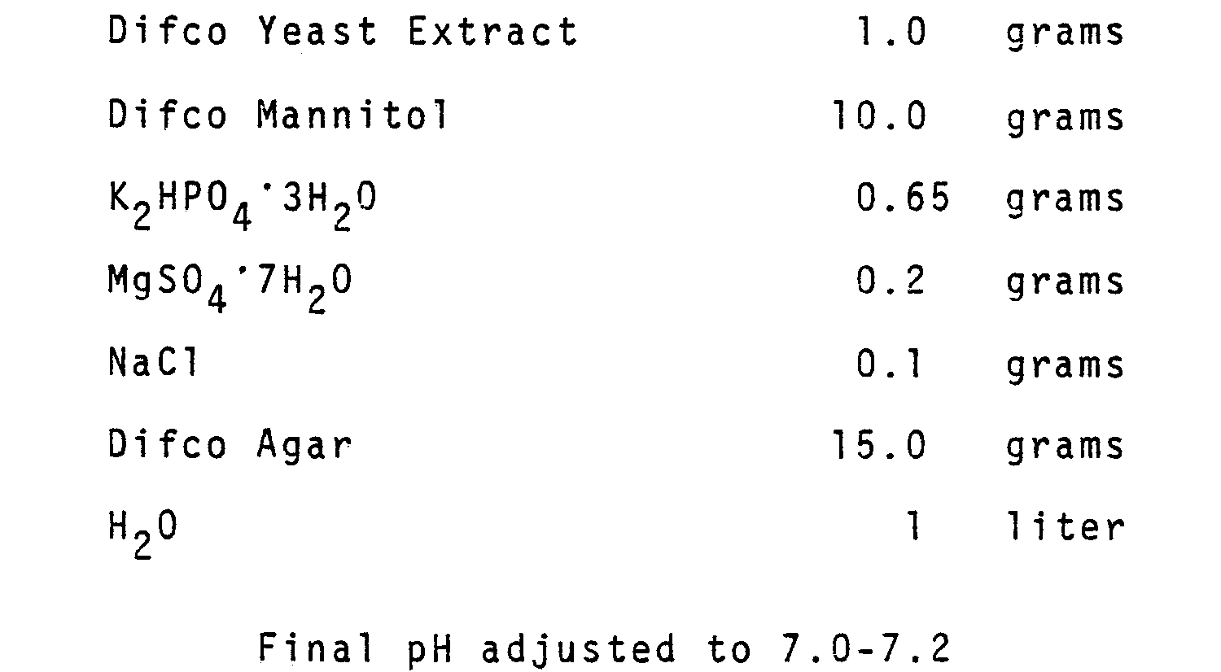

MATERIALS AND METHODS

Source and Maintenance of Cultures

Table 1 shows the strains of Rhizobium leguminosarum used in this study and their origin. All strains were maintained on yeast extract mannitol (Bohlool and Schmidt, 1970), which had the following composition:

All strains were grown in broth with the same composition as above. All media were sterilized by autoclaving at 20 lb. (121˚C) for 20 minutes.

Lentil Seeds, Surface Sterilization, and Plant Growth: Growth Chamber.

Lentil seeds were surface-sterilized with 4% calcium hypochlorite for 15 minutes, rinsed six times in sterile water, and germinated aseptically in petri dishes containing 1% water agar. For strain screening, Growth Chamber Competition Experiment I, and all field experiments, lentil seeds of a commercial
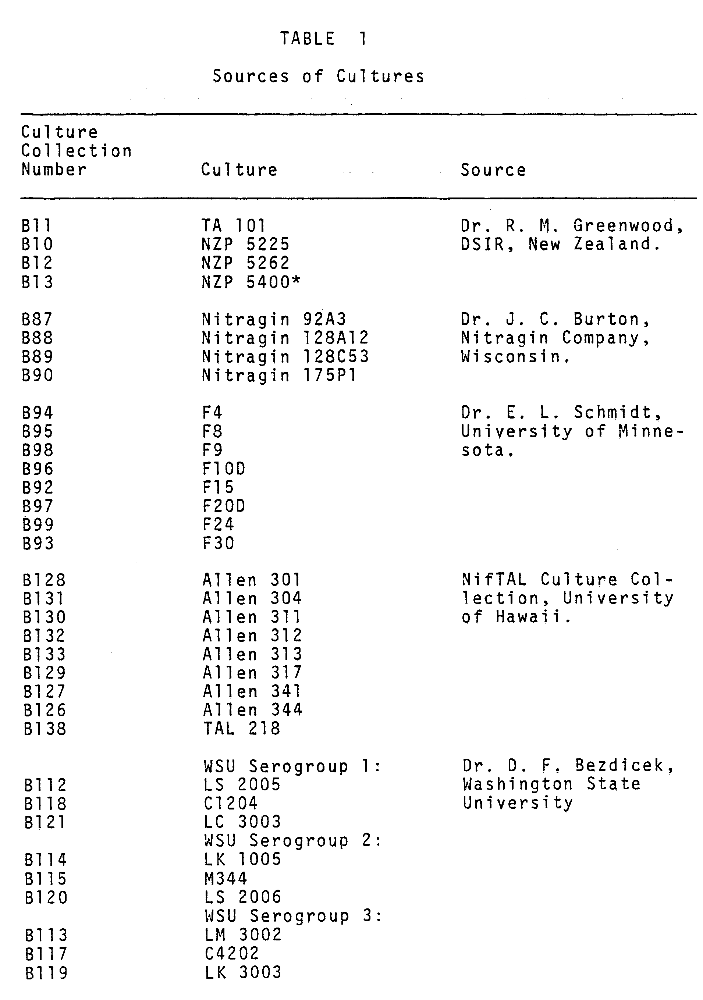
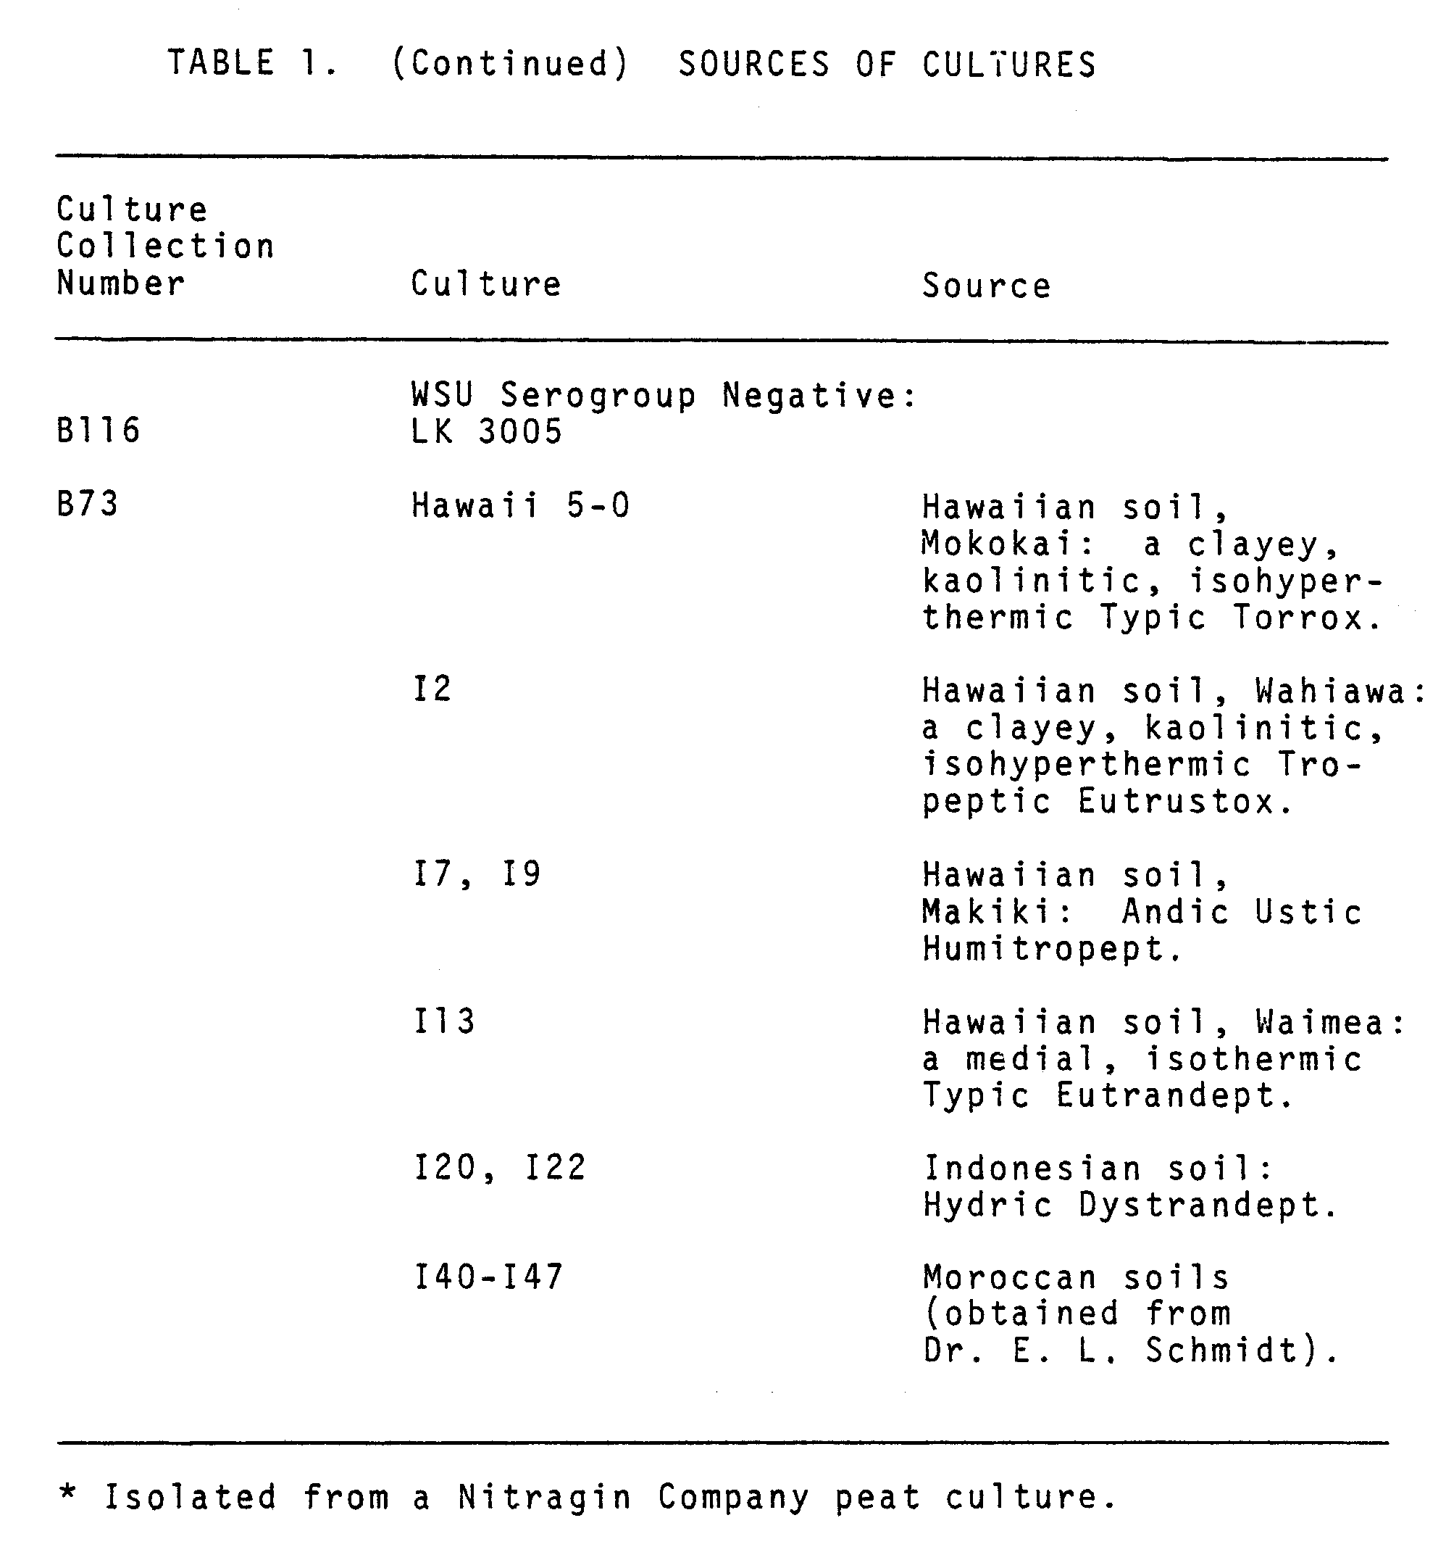
variety were used. These seeds were provided by Dr. D. Munns and originated from Spokane Seed Company, Spokane, Washington. In Growth Chamber Competition Experiment II three lentil cultivars were used: Tekoa (a variety), Benewah (a pure line cultivar) and commercial Chilean (neither a variety nor a pure line). These were provided by Dr. D. F. Bezdicek, Department of Agronomy and Soils, Washington State University, Pullman, Washington, who obtained them from Dr. Van Wilson, USDA lentil geneticist. For strain screening each lentil seedling was planted in a 25 x 200 mm sterile test tube unit containing vermiculite and nitrogen-free nutrient solution (Broughton and Dilworth, 1971). In growth chamber competition experiments seedlings were planted in modified Leonard jars (Leonard, 1943), which contained sterile vermiculite and a nitrogen-free nutrient solution (Broughton and Dilworth, 1971) which had the following compositions (For each 10 liters of complete culture solution 5.0 ml each of solutions 1 to 4, was added to 5.0 liters of water and diluted to 10 liters.)
Strain Screening
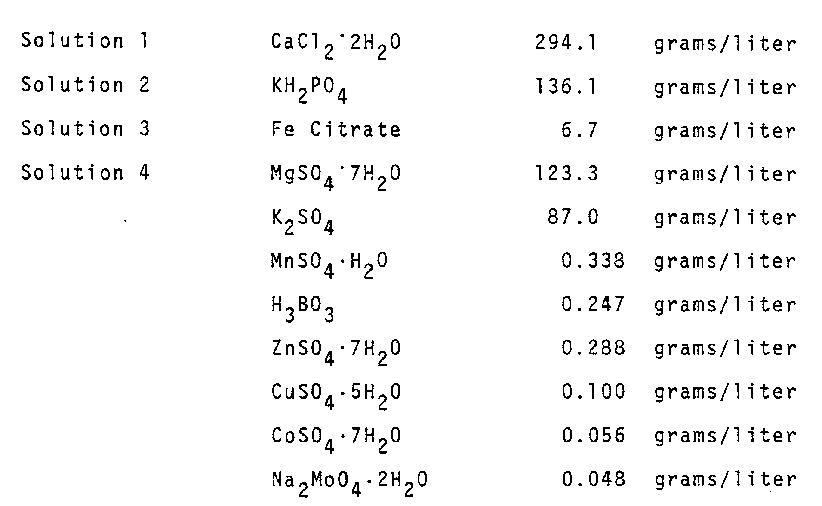

All available cultures were screened for effectiveness on lentils. Exceptions were: the 0. N. Allen strains, TAL strain, and those provided by Dr. D. F. Bezdicek. These were not available during the initial screening period. Slants of each culture were washed with 2 ml. of sterile water. Each of two 25 x 200 mm sterile test tube units, containing one lentil seedling, received 1 ml of inoculum. Eight units were left uninoculated. After inoculation, a 1 cm. layer of sterile perlite was added to each tube. Plants were grown in an EGC Model M-31 growth chamber (Environmental Growth Chambers, Chagrin Falls, Ohio) with a 14 hour day and a day/night temperature of 29°C/24°C. Plants were watered daily with sterile nitrogen-free nutrient solution. After four weeks each tube was stoppered and injected with 5.0 ml of acetylene to analyze for nitrogenase activity (Hardy et al., 1968). After 30 minutes incubation, 0.5 ml was removed from each tube and injected into a Bendix-2500 gas chromatograph equipped with an H₂ flame ionization detector and a Poropak-T column at 105°C.

Preparation of Fluorescent Antibodies (FA), Immunofluorescent (IF) Staining, and Microscopy.

Fluorescent antibodies were prepared against the somatic components of NZP 5400, Hawaii 5-0, and Nitragin strains 128A12, 128C53, and 175P1. Preparation of antisera and conjugation procedures were according to Schmidt et al. (1968) except cultures were grown in YEMS broth for three days instead of seven days. Smears from pure cultures and nodules were stained by the method of Schmidt et al. (1968), using gelatin-rhodamine isothiocyanate conjugate to control nonspecific staining and autofluorescence (Bohlool and Schmidt, 1968). Stained nodule and culture smears were observed on a Zeiss universal microscope equipped for epifluorescence and transmitted dark field. Incident illumination was from an HBO-200 (OSRAM) light source with a fluoroscein isothiocyanate (FITC) filter. Transmitted dark field was from a 12V quartz halogen lamp, using a Zeiss Ultracondenser. Photographs were taken with a Leica camera, using Kodak Tri-X for black-and-white, and Kodak Ektachrome 200 for color.

Test for Cross-Reacting Bacteria at Field Sites.

Prior to the installation of the field experiments, lentils were grown in pots containing the uninoculated field soil. After nodules developed, nodule isolates were stained with each FA. A soil sample from each field site was stained by the FA membrane filter technique of Bohlool and Schmidt (1973a), using 25 mm diameter polycarbonate filters (Nuclepore) pretreated with Irgalan Black (Hobbie et al. 1977) and the gelatin-rhodamine isothiocyanate conjugate was allowed to dry completely on each filter prior to IF staining.

Growth Chamber Competition Experiment I: Commercial Seeds

In this experiment three seedlings were planted in each Leonard jar. Dilutions of three-day-old shake flask cultures of NZP 5400, Hawaii 5-0, and Nitragin 128A12 were counted using the FA membrane filter technique. Stock solutions, each containing 1 x 10⁶ rhizobia/ml, were prepared for each strain and all possible multistrain combinations. Double strain inocula contained equal proportions of two strains and the triple strain inocula contained equal proportions of all three strains. Each of the three seedlings in a jar received 1 ml of a particular inoculum mixture and two jars were left uninoculated. A 1 cm layer of sterile perlite was added to all the jars. The design of the experiment was a randomized complete-block with three replicates. Plants were grown in the growth chamber for four weeks.

Growth Chamber Competition Experiment II: Strains x Cultivars

The three lentil cultivars, Benewah, Chilean, and Tekoa were grown in Leonard jars and inoculated with all possible combinations of NZP 5400, Hawaii 5-0 and Nitragin 128A12 as above. This experiment was not replicated.

Sampling and Staining of Nodules: Growth Chamber Competition Experiments I and II

Plants were harvested after four weeks. Tops were removed and each root was placed in a 60 ml serum bottle. The bottles were stoppered and injected with 6 ml of acetylene to assay for nitrogenase activity (Hardy et al. 1968). After 30 minutes incubation, 0.5 ml was removed from each bottle and injected into the gas chromatograph. Roots from each bottle were washed in distilled water containing .1% Tween-80 and rinsed four times to remove any rhizobia which may have been present on the root surface. Nodules were surface sterilized in mercuric chloride and a random sample of at least 50% of the nodules from each plant was removed for FA staining. Each nodule was touched to the surface of at least four slides, and stained with the appropriate FA.

Field Experiment I: Two Strain Competition

Hawaii 5-0 and NZP 5400 were grown separately for five days at 30°C in gamma irradiated peat (Roughley and Vincent, 1967). Serial dilutions of the peat were counted by the FA membrane filter technique and by viable count. Each culture contained 9 x 10⁸ rhizobia/gm. Peat was coated onto lentil seeds using 40% gum arabic, and four seed coating treatments were employed: sterile peat, peat containing Hawaii 5-0 or NZP 5400 only, or a peat mixture which contained equal numbers of both strains. All coated seeds were pelleted with calcium carbonate (Brockwell, 1962), and the total rhizobia/seed was 5 x 10⁴, as determined by the FA membrane filter technique and viable count. Seeds were planted at the Mauka Field Station of the University of Hawaii in a randomized complete-block design in three replicates. The soil, Makiki stony clay, an Andic Ustic Humitropept, pH 6.1, contained a low number of ineffective rhizobia (less than 100) as determined by the most-probable number method (Date and Vincent, 1962).
After ten weeks, ten plants were harvested from each treatment. Roots were removed and tested for nitrogenase activity by the acetylene reduction assay as described above. Plant tops were dried in a 60°C oven and weighed after drying. Roots were washed as above and nodules were counted and pooled from each treatment. A random sample of 50 nodules/treatment/replicate was stained according to the protocol above.

Field Experiment II: Persistence

One year after the installation of Field Experiment I, uninoculated lentil seeds were coated with gamma irradiated peat and calcium carbonate and were planted in the same experimental plots as Field Experiment I. The plots had been left undisturbed since the previous harvest.
Ten plants from each treatment were harvested after ten weeks and were analyzed as above. However, a random sample of at least eight surface sterilized nodules was removed from each plant and stained as previously described.

Field Experiment III: Three Strain Competition

Hawaii 5-0, NZP 5400, and Nitragin 128A12 were grown separately for five days at 30°C in gamma irradiated peat (Roughley and Vincent, 1967). Dilutions of the peat were counted as in Field Experiment I and all three peat cultures were mixed just prior to seed coating in proportions adjusted to allow for equal numbers of all three strains. The peat mixture was coated onto lentil seeds as before. The total rhizobia/seed was 1.85 x 10⁵. Inoculated and uninoculated seeds were planted at the Poamoho Research Station of the University of Hawaii. The soil, Wahiawa silty clay, a clayey, kaolinitic, isohyperthermic Tropeptic Eutrustox, had a pH of 5.8. Seeds were planted in three different phosphorus treatments: low (.003 ppm phosphorus in solution), medium (.05 ppm phosphorus in solution), and high (.8 ppm phosphorus in solution)(Fox and Kamprath, 1970). The design of the experiment was an augmented block in which the low and high levels were not replicated, but the medium level was replicated three times. These plots were generously provided by Dr. Robert L. Fox, University of Hawaii.
Plants were harvested at ten days, five weeks, and eight weeks. Roots were washed and surface sterilized as above; however, nodules were preserved by drying them in a 60°C oven. For the ten-day sampling, every nodule on at least six plants for each treatment was typed by immunofluorescence. At the five-week sampling period, ten plants were harvested from each treatment and over 25% of the nodules were typed. Acetylene reduction was performed on 15 plants from each treatment in the eight-week group, and 25% of the nodules were typed. Acetylene reduction was done by placing three plants from the same treatment in a tube (280 ml vol.), which was stoppered and injected with 10% acetylene at the field site. Samples were brought back to the lab and analyzed for nitrogenase activity as above.

Relative Numbers of Rhizobia in the Rhizosphere of Lentils.

At the termination of Field Experiment I, soil cores with an approximate volume of 200 cc were taken from the root zone of 16 remaining plants. This represented four plants from each inoculation treatment. As much plant material as possible was removed from each soil sample. The soil was dried in a 105°C oven and sieved thru a 2 mm mesh sieve to remove all root and module material. Each soil sample was thoroughly mixed and the numbers of Hawaii 5-0 and NZP 5400 in a 10 g sample from each core were counted by the FA membrane filter technique of Bohlool and Schmidt (1973).

Statistical Analysis of Competition between Strains

Chi-square analysis was used to assess the competitiveness of Rhizobium strains in both growth chamber and field experiments. In two strain competition the number of singly-infected nodules produced by one strain relative to the second strain was analyzed as a 50:50 ratio, as this was the ratio of the two strains in the applied inoculum. The ratio of single strain:single strain:double strain nodules was analyzed as a 1:1:1 ratio. In three strain competition the number of nodules produced by each single strain was analyzed as a 33:33:33 ratio as this was the ratio of the three strains in the applied inoculum. In comparing three strain competition in the growth chamber to three strain competition in the field, results of Growth Chamber Competition Experiment I were used as the expected values. The observed values were those obtained at the five-week sampling period in the medium phosphorus level of Field Experiment III. Thus, the plants were at the same stage of growth, the same cultivar of seeds were used, and both experiments were replicated three times.
CHAPTER 4
RESULTS

Strain Screening

Results of the acetylene reduction strain screening are shown on Table 2. Of the 31 strains or isolates screened, 11 were ineffective and five were highly effective.

Fluorescent Antibodies (FA)

The FA prepared against NZP 5400, Hawaii 5-0, and Nitragin strains 128A12, 128C53, and 175P1 exhibited a high degree of strain specificity as shown on Table 3. The FA prepared against the three strains used in all further experiments (NZP 5400, Hawaii 5-0, and Nitragin 128A12) reacted 4+ only with the homologous bacteria. This includes rhizobia isolated from the experimental sites and over 40 other strains of Rhizobium leguminosarum tested. In addition, these FA did not react with bacteria recovered from field site soils.

Growth Chamber Competition Experiment I

Results of this experiment are shown on Table 4. Uninoculated controls were nodule-free and single-strain inoculated plants had nodules containing only the inoculum strain. In two strain competition NZP 5400 and Hawaii 5-0 were equal in competitive ability and 300 of the nodules contained both strains. Chi-square analysis of the ratio of Hawaii 5-0:NZP 5400 revealed that each strain produced an equal number of nodules (x²=1.92, 1 degree of freedom (df)). The ratio of Hawaii 5-0:NZP
5400:mixed did not differ significantly from a 1:1:1 ratio (x²=2.47, 2 df).
NZP 5400 dominated Nitragin 128A12, and 3% of the nodules were doubly-infected. There was a significant departure (P <.Ol) from a 50:50 ratio of NZP 5400:Nitragin 128A12 (x²=85.37, 1 df). The ratio of NZP 5400:Nitragin 128A12: mixed was significantly different (P <.Ol) from 1:1:1 (x²=165.62, 2 df).
Hawaii 5-0 was superior to Nitragin 128A12 and the ratio of Hawaii 5-0:Nitragin 128A12 deviated significantly (P <.Ol) from 50:50 (x²=15.80, 1 df). Eighteen percent of the nodules were doubly-infected. Again, there was a significant departure (P <.Ol) from a 1:1:1 ratio of Hawaii 5-0: Nitragin 128A12:mixed (x²=30.02, 2 df).
Plants which received the mixture of all three strains were nodulated mainly by Hawaii 5-0 and NZP 5400, and the two were equal in competitive ability. Nitragin 128A12 produced 2% of the nodules. There was a significant departure (P <.Ol) from a 1:1:1 ratio of nodules produced by each single strain (x²=41.87, 2 df). In the case of double infection, 18% and 12% of the nodules contained both Hawaii 5-0 and Nitragin 128A12 or Hawaii 5-0 and NZP 5400 respectively. Only 3% of the nodules contained both NZP 5400 and Nitragin 128A12. None of the nodules contained all three strains.
Figure 1 is a representative microscope field of a smear of a nodule which contained one strain of R. leguminosarum. This slide was stained with the FA for Hawaii 5-0. Figure 2 is a representative microscope field of a smear of a nodule which contained two serologically distinct strains of R. leguminosarum. Bright cells are Hawaii 5-0 and were stained with the FA specific for this strain. Dimmer cells, visualized by dark field illumination, represent Nitragin 128A12.

Growth Chamber Competition Experiment II

Results of this experiment are shown in Table 5. The chi-square values are also shown in this table. In two strain competition, Hawaii 5-0 and NZP 5400 were approximately equal in competitive ability on both Tekoa and Benewah. NZP 5400 was superior to Hawaii 5-0 on the Chilean cultivar. Again a high percentage of nodules contained both NZP 5400 and Hawaii 5-0.
On all three cultivars NZP 5400 dominated Nitragin 128A12, and less than 6% of the nodules contained both strains.
Nitragin 128A12 and Hawaii 5-0 were approximately equal in competitive ability on Tekoa and Chilean. Nitragin 128A12 dominated Hawaii 5-0 on Benewah. Between 0% and 36% of the nodules contained both strains, depending on the cultivar.

Field Experiment I: Two Strain Copetition

Table 6 shows that in this experiment all of the nodules on the single-strain inoculated plants (commercial variety) contained only the inoculum strain, even though a low number of ineffective rhizobia were present in this soil. Control plants were also nodulated, but analysis of variance revealed that the controls had significantly fewer (P=.05) nodules than either of the inoculated treatments. The majority of the control nodules did not react with either fluorescent antibody and were produced by the “native” strains of rhizobia. Only 12% of the control nodules reacted with FA for NZP 5400 and 6% with FA for Hawaii 5-0. A more critical examination of other control plants revealed that the control rows had been contaminated late in the experiment by Hawaii 5-0

Figure 1. Microscope field of a smear of nodule which
contained only one strain of Rhizobium legu-
minosarum.

Figure 2. Microscope field of smear of a nodule which
contained two serologically distinct strains
of Rhizobium leguminosarum. Bright cells are
Hawaii 5-0 and were stained with the fluores-
cent antibody specific for this strain. Dim-
mer cells in the background are visualized by
darkfield illumination and represent Nitragin
128A12.

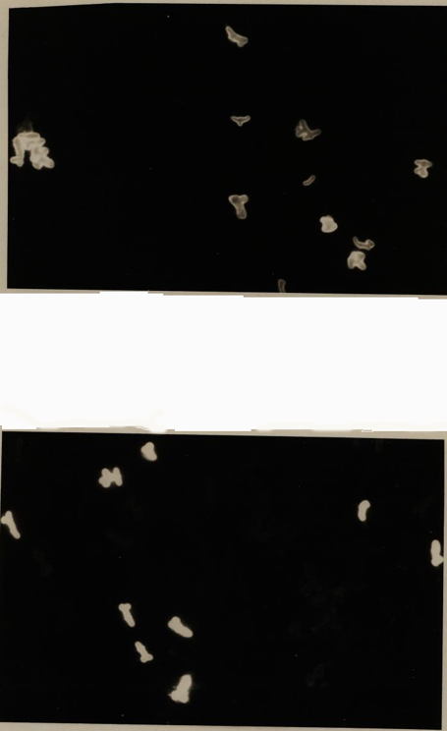

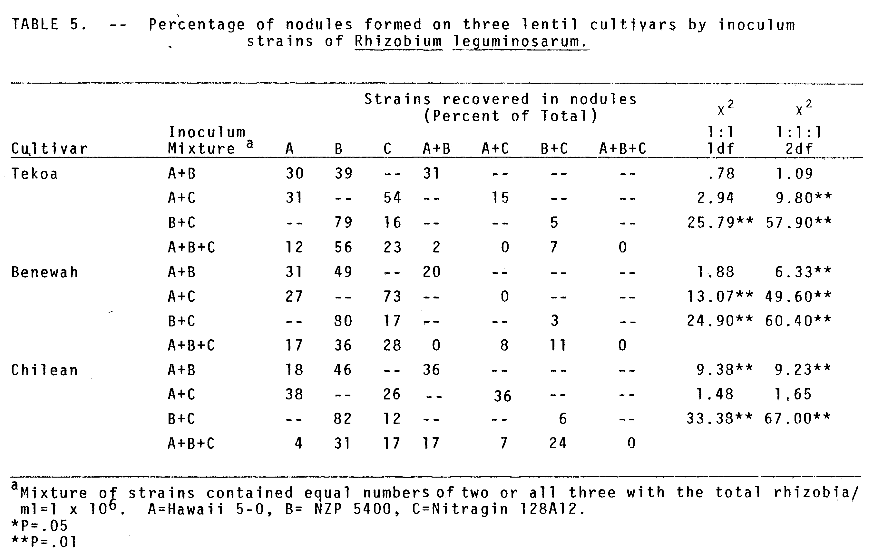
or NZP 5400. Nodules on the main root, close to the seed did not react with either FA.
Competition between Hawaii 5-0 and NZP 5400 resulted in equal numbers of nodules being produced by each single strain. The ratio of Hawaii 5-O:NZP 5400 nodules did not differ significantly (P> .05) from 50:50 (x²=.10, 1 df). A high percentage (38%) of doubly-infected nodules occurred. The ratio of Hawaii 5-O:NAP 5400:mixed did not differ significantly (P >.05) from a 1:1:1 ratio ( x²=1.56, 2 df).
Statistically there was no significant difference between treatments with respect to plant dry weights. However, acetylene reduction values between treatments differed significantly (P=.05). Controls reduced significantly (P=.05) less acetylene than the three inoculated treatments, and the plants which received the double-strain inoculum reduced significantly more acetylene than either of the single-strain inoculated plants.

Field Experiment II: Persistence

Table 7 shows that both NZP 5400 and Hawaii 5-0 persisted in this particular soil for a one-year period. With the exception of the control rows, less than 10% of the nodules were formed by "native" strains. Plants grown in rows which had been previously inoculated with both strains had 51% of their nodules formed by Hawaii 5-0, 19% by NZP 5400, and 24% contained both strains. The ratio of Hawaii 5-O:NZP 5400 nodules differed significantly (P <.Ol) from 50:50 (X²=34.38, 1 df). The ratio of Hawaii 5-O:NZP 5400: mixed differed significantly (P <.Ol) from 1:1:1 ( X²=44.32, 2 df).

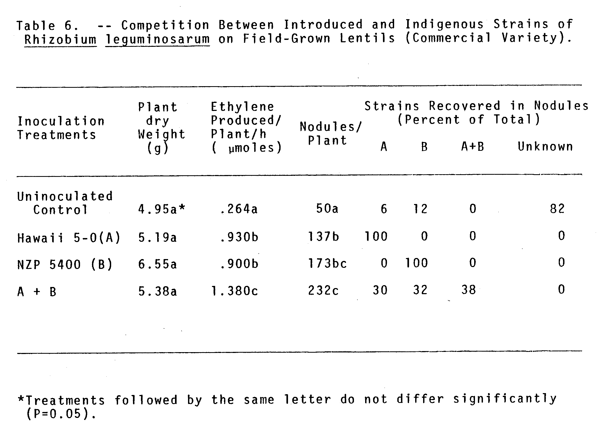
Field Experiment III: Three Strain Competition

Results of the 10-day, 5-week, and 8-week sampling periods at all three phosphorus levels are shown on Table 8. In the low phosphorus level, Hawaii 5-0 was superior to the other two strains. In the medium phosphorus level, with the exception of the 5-week sampling period, Hawaii 5-0 and Nitragin 128A12 were equal in competitive ability. The ratio of the number of nodules produced by each of these two strains did not differ significantly (P>.05) from 50:50 (X²=1.69, ldf, 10-day period; X²=2.48, 1 df, 8-week period). In the high phosphorus level, with the exception of the 5-week sampling period, all three strains were equal in competitive ability.
Approximately 50% of the uninoculated control plants were nodulated at the 8-week sampling period. However, the mean number of nodules on each control plant was 6 compared to 18 on each plant which had been inoculated. Immunofluorescence typing of the control nodules revealed that they were all formed by the three introduced strains.
The acetylene reduction assay performed at 8 weeks revealed that there was no significant difference between phosphorus levels in ethylene produced/plant/hour (F=1.03, 4 df).
Table 9 is a summary of three strain competition in Growth Chamber Experiment I vs. Field Experiment III (medium phosphorus level, 5-week sampling period.) Hawaii 5-0 formed a high percentage of nodules in both the growth chamber and in the field. NZP 5400 performed better in the growth chamber than in the field. Nitragin 128A12 performed better in the field than in the growth chamber. The proportion of doubly infected nodules in both growth chamber and the field was the same.
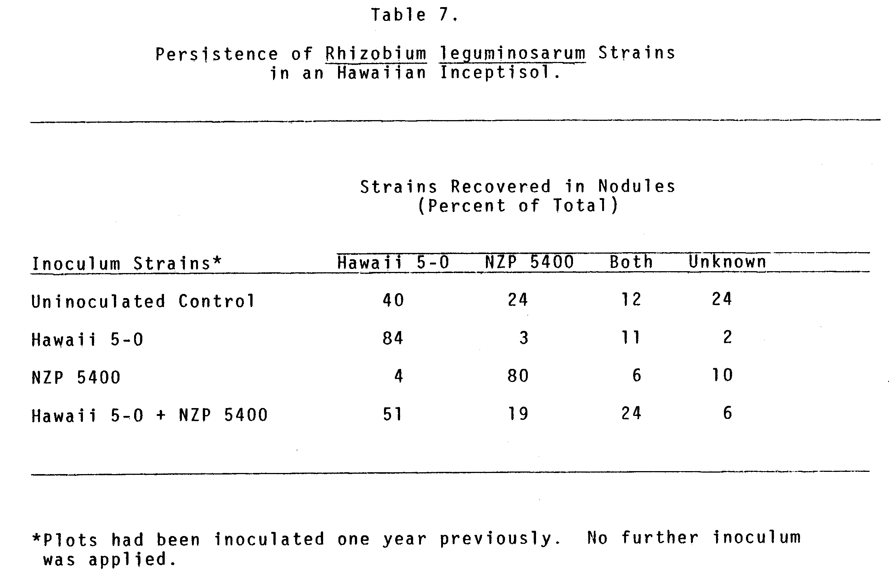
Relative Numbers of Rhizobia in the Rhizosphere of Lentils.

Table 10 shows the number of bacteria recovered from the soil cores at the termination of Field Experiment I. The ratio of Hawaii 5-O:NZP 5400 in treatments inoculated with a 50:50 ratio of the two strains differed significantly (P <.Ol) from 50:50 ( x²=8.19, 1 df).
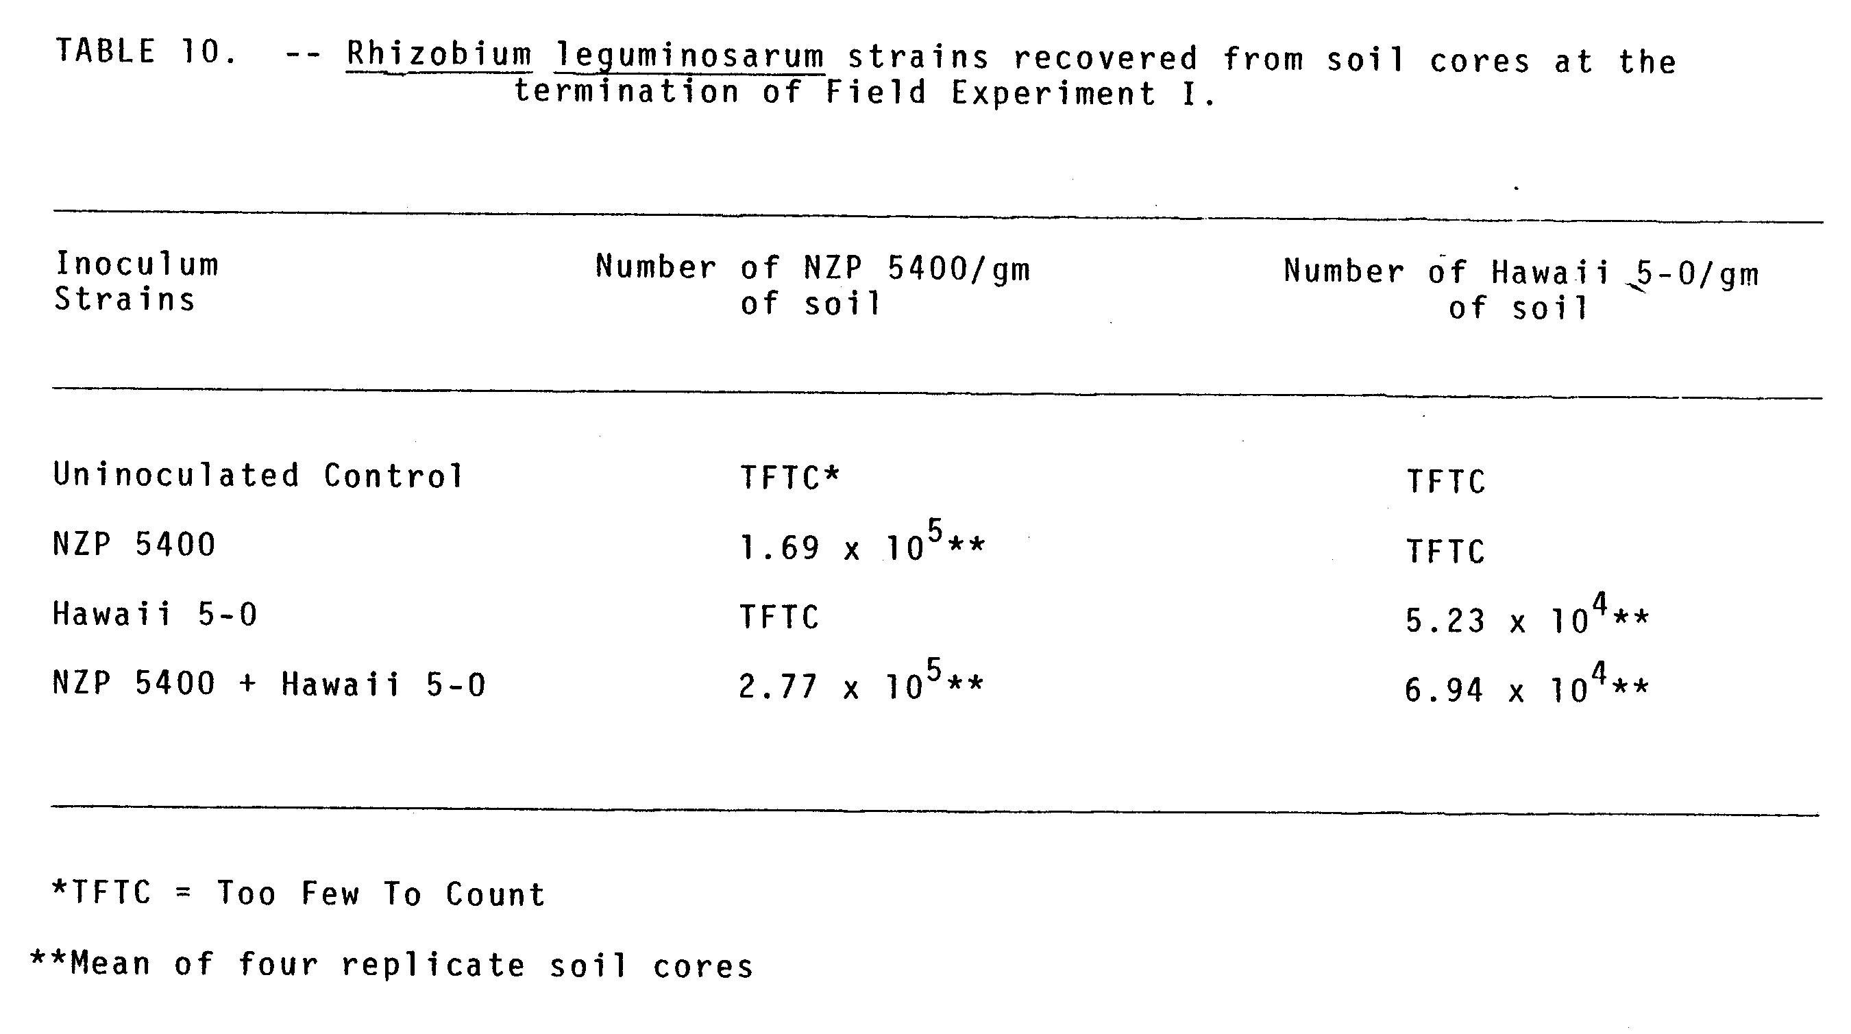
CHAPTER 5
DISCUSSION

In these studies twenty of thirty-one strains/isolates of Rhizobium leguminosarum were shown to have varied degrees of effectiveness on lentils. The remaining strains were ineffective and thus did not benefit the host plant.
Three of the most effective strains, NZP 5400, Hawaii 5-0, and Nitragin 128A12, were serologically distinct as determined by immunofluorescence microscopy and also by an enzyme-linked immunosorbent assay (Berger et al. 1979). The specificity of the fluorescent antibodies (FA) prepared against the three strains made it possible to use all three strains in various combinations to inoculate lentils and to easily identify the strains present in individual lentil nodules.
In both a replicated growth chamber experiment (I) and in one field experiment (I) NZP 5400 and Hawaii 5-0 were equally competitive. In this field experiment none of the nodules on inoculated lentils were formed by native strains. This could either be due to the high levels of inocula which were applied directly to the seed or, these strains are more competitive than the indigenous population of ineffective lentil rhizobia. Both strains persisted in this field over one year and the indigenous strains only formed 10% or less of the nodules, with the exception of the control plants. Control plants were nodulated mainly by both of the previously introduced strains and only 24% of the nodules contained the indigenous strains. This implies that NZP 5400 and Hawaii 5-0 had not only survived in this soil, but also were more competitive than the "native" strains without having had the advantage of being strategically placed directly on the seed. The locally isolated strain, Hawaii 5-0, was present in over 50% of the nodules in rows which had been inoculated one year previously with both strains. Thornton (1943) found that locally isolated strains of R. trifolii persisted in greater numbers than commercial strains in two out of three instances.
According to Fred et al. (1932) phosphates are distinctly stimulating to the multiplication of rhizobia, however, to this author's knowledge the effect of phosphorus concentrations on the competitiveness of Rhizobium strains has not previously been assessed. Field Experiment III results revealed that the concentration of the limiting nutrient, phosphorus, did have an effect on the competitiveness of the three strains. In a comparison of both early (10 day) and late (8 week) nodulation, Hawaii 5-0 was superior to the other strains at the low phosphorus level. Hawaii 5-0 and Nitragin 128A12 were equally competitive at the medium level. All three strains were equally competitive at the high level of phosphorus. Thus, in the most stressed situation (low phosphorus) the locally isolated strain was more competitive than either of the two commercial strains.
In 1941 Nicol and Thornton related competition between Rhizobium strains to relative growth rates of the strains used as inocula. Other investigators have failed to relate growth rates with competitiveness (Baird, 1953; Read, 1953, Vincent and Waters, 1953). In Field Experiment I, the two strains Hawaii 5-0 and NZP 5400 were equally competitive, however, at the termination of this experiment, recovery from soil cores from plants which had received the two-strain inoculum revealed that NZP 5400 was present in higher numbers than Hawaii 5-0. If one can assume that both strains can be recovered with equal efficiency from this soil, then growth rates and competitiveness are not related characteristics in the case of these two strains and this particular soil, and the ability to compete may be under genetic control.
In 1954 Vincent reported that with clover species the host variety preferentially selects one strain over another. Growth Chamber Experiment II results of two strain competition revealed that the genotype of the host did have an effect on the competitiveness of Hawaii 5-0 and Nitragin 128A12. Some difference was observed in the performance of Hawaii 5-0 and NZP 5400, but no differences were observed with respect to NZP 5400 and Nitragin 128A12, in that NZP 5400 dominated Nitragin 128A12 on all three cultivars.
Read (1953) showed that at different sites, different strains of R. trifolii became better established. Although a two-strain inoculum was used at one site in Field Experiment I and a three-strain inoculum was used at the second site in Field Experiment III the competitiveness of NZP 5400 and Hawaii 5-0 will be compared. In Field Experiment I, Hawaii 5-0 and NZP 5400 were equally competitive against each other, but in Field Experiment III, Hawaii 5-0 was dominant against NZP 5400 at both the low and medium levels of phosphorus. Read (1953) suggested that because strains establish differently in different localities multistrain inoculants should be used. This has also been proposed by other investigators (Burton and Allen, 1949; Read, 1953; Vincent, 1954; Marshall, 1956; Roughley, 1970), provided all strains included are effective on the host plant (Burton and Allen, 1949; Jones and Russell, 1972). In addition, several investigators have shown that plants inoculated with mixtures of effective strains had the best growth and the highest content of nitrogen (Burton and Allen, 1949; Dorosinskii and Makarova, 1976; Bordeleau and Antoun, 1977). It is the opinion of this author that the three effective strains, NZP 5400, Hawaii 5-0, and Nitragin 128A12, should be used as a multistrain inoculum on lentil seeds.
In three strain competition Hawaii 5-0 formed the majority of lentil nodules under both bacteriologically controlled and field conditions (comparing results shown on Table 9). The competitive ability of the other two strains changed under field conditions. Nitragin 128A12, a poor competitor in the growth chamber, established and competed well in the field. NZP 5400, a good competitor in the growth chamber, was a poor competitor in this particular field. Means et al. (1965) observed that USDA 110 was a superior competitor in both the greenhouse and in the field, but the second ranking strain in greenhouse tests, USDA 121, was unsuccessful in field trials. Thus, under field conditions competition between strains can be altered by many factors. The poor performance of NZP 5400 in the field could be due to environmental factors such as moisture, temperature or pH. The pH of the field soil (5.8) was lower than the vermiculite-nutrient medium used in the growth chamber study (6.5-7.0) and pH has been shown to affect dominance in competition (Jones and Russell, 1975).
The specificity of the fluorescent antibodies prepared against the somatic components of Hawaii 5-0, NZP 5400 and Nitragin 128A12 made it easy to identify the strain(s) present in individual lentil nodules. The importance of pre-testing field soils for cross-reacting strains of infective rhizobia and other soil bacteria deserves emphasis. In Field Experiment I it would not have been possible to enumerate rhizobia accurately from the soil, had crossreacting bacteria been present. In Field Experiment III the uninoculated controls developed nodules between 5 and 8 weeks. Since no serologically cross-reactive strains were previously isolated from this soil, controls must have been contaminated by the three introduced strains as all control nodules contained rhizobia which reacted 4+ with one of the three FA's.
Immunofluorescence provided a sensitive means to identify the simultaneous presence of two strains in the same nodule. In both growth chamber and field experiments a high incidence of double infection was observed. In 1974 Lindemann et al. used immunofluorescence to provide evidence for double infection in soybean nodules and reported 32% double infections. Prior to this double infection was observed infrequently and was believed to be a rare occurrence (Vincent, 1954; Means et al. 1961). However, the techniques used by these investigators do not have the sensitivity of immunofluorescence. In 1970 Skrdleta reported that only 10% of soybean nodules could contain two strains of Rhizobium japonicum. Skrdleta used immunodiffusion for nodule strain identification and this technique relies on a critical antigen (strain) to antibody ratio. Thus, if two strains were present in the same nodule one strain would not be detected if its concentration were below the optimum required for precipitin line development. Since 1974 other investigators have reported double infection for alfalfa, clover, pea, and siratro (Pinto et al. 1974; Labandera and Vincent, 1975; Johnston and Beringer, 1975; Franco and Vincent, 1976), but the highest incidence reported was 25% (Marques Pinto et al. 1974). All of these investigators used differential antibiotic resistance markers for Rhizobium strain identification. Brockwell et al. (1977) compared the streptomycin-resistance marker technique to immunodiffusion and reported that the marker technique would probably fail to detect cases of mixed infection if the resistant strain outnumbered the sensitive strain, as the former would overgrow the latter on non-streptomycin agar. Furthermore, antibiotic resistance markers should be used with caution in competition experiments as Jones and Bromfield (1978) reported that the majority of singly and doubly labeled mutants that they tested were inferior to the parental strains in both effectiveness and competitiveness.
The results of two strain competition in Growth Chamber Experiment I and Field Experiment I revealed that two strains, Hawaii 5-0 and NZP 5400 were equally competitive and one-third of the nodules were doubly infected. In the same growth chamber experiment NZP 5400 dominated Nitragin 128A12 and only 3% of the nodules contained both strains. These results show there appears to be a relationship between competitiveness and the incidence of double infection.
Some investigators (Marques Pinto et al. 1974; Labandera and Vincent, 1975) have reported that double infection in both alfalfa and clover nodules varies depending on the species of host. Growth Chamber Experiment II, however, has reinforced evidence that in two-strain competition at least with three lentil cultivars double infection is frequent if two strains are equally competitive, and rare if one strain dominates another. Jones and Bromfield (1978) reported that double infection in colver nodules varied from 1% to 22% depending on the strain pairs used in the mixed inoculum. This could also be true with lentils, since in all two-strain competition experiments NZP 5400 and Nitragin 128A12 had fewer than 6% doubly-infected nodules. These two strains did not form greater than 11% double infections in three strain competition except in the case of the Chilean cultivar in Growth Chamber Competition Experiment II. In three strain competition in Field Experiment III the percentage of nodules doubly-infected by both NZP 5400 and Nitragin 128A12 was always very low and did not change over time, nor between phosphorus treatments.
Jones and Bromfield (1978) reported lower frequencies of mixed infection on clover plants grown in soil compared with those grown in agar tube culture. However, in all of these experiments field-grown lentils and vermiculite-grown lentils had a high incidence of doubly-infected nodules, and this phenomenon was related to competition.
Under the conditions of these experiments three highly effective and competitive strains of Rhizobium leguminosarum have been selected. These strains have only been tested in the growth chamber and in Hawaiian soils with low populations of indigenous lentil rhizobia. Before these strains can be recommended as inocula their competitiveness and persistence should be assessed in other localities under different conditions.
BIBLIOGRAPHY

Amarger, M. 1974. Competition pour la formation des nodosites sur la feverole entre souches de Rhizobium leguminosarum apportees par inoculation et souches indigenes. C. R. Hebd. Seances Acad. Sci. Ser. D. Sci. Nat. 279: 527-530.

Baird, K. J. 1953. Clover root-nodule bacteria in the New England Region. Internal Rep. Univ. Sydney.

Berger, J. A., S. M. May, L. R. Berger, and B. B. Bohlool. 1979. Colorimetric enzyme-linked immunosorbent assay for the identification of strains of Rhizobium in culture and in the nodules of lentils. Appl. Environ. Microbiol 37: 642-646.

Bergersen, F. J. 1970. Some Australian studies relating to the long-term effect of the inoculation of legume seeds. Plant Soil 32: 727-736.

Bohlool, B. B. and E. L. Schmidt. 1968. Nonspecific staining: --its control in immunofluorescence examination of soil. Science 162: 1012-1014.

Bohlool, B. B. and E. L. Schmidt. 1970. Immunofluorescent detection of Rhizobium japonicum in soils. Soil Sci. 110: 229-236.

Bohlool, B. B. and E. L. Schmidt. 1973. Persistence and competition aspects of Rhizobium japonicum observed in soil by immunofluorescence microscopy. Soil Sci. Soc. Am. Proc. 37: 561-564.

Bohlool, B. B. and E. L. Schmidt. 1973a. A fluorescent antibody technique for determination of growth rates of bacteria in soil. Bull. Ecol. Res. Comm. (Stockholm) 17: 336-338.

Bordeleau, L. M. and H. Antoun, 1977. Effet de l’inoculation mixte avec des couches de Rhizobium meliloti sur le rendement de la luzerne, cultivar saranac. Can. J. Plant Sci. 57: 1071-1075.

Brockwell, J. 1962. Studies on seed pelleting as an aid to legume seed inoculation-- I. Coating materials, adhesives, and methods of inoculatoin. Aust. J. agric. Res. 13: 638-649.

Brockwell, J. and W. F. Dudman. 1968. Ecological studies of root-nodule bacteria introduced into field environments--II. Initial competition between seed inocula in the nodulation of Trifolium subterraneum L. seedlings. Aust. J. Agric. Res. 19: 749-757.

Brockwell, J. E., A. Schwinghamer, and R. R. Gault. 1977. Ecological studies of root-nodule bacteria introduced into field environments-- V. A critical examination of the stability of antigenic and streptomycin-resistance markers for identification of strains of Rhizobium trifolii. Soil Biol. Biochem. 9: 19-24,

Broughton, W. J. and M. J, Dilworth. 1971. Control of leghaemoglobin synthesis in snake beans. Biochem. J. 125: 1075-1080.
Burton, J. C. and O. N. Allen. 1949. Inoculation of crimson clover (Trifolium incarnatum L.) with mixtures of rhizobia strains. Proc. Soil Sci. Soc. Amer. 14: 191-195.

Caldwell, B. E. 1969. Initial competition of root-nodule bacteria on soybeans in a field environment. Agron. J. 61: 813-815.

Caldwell, B. E. and G. Vest. 1968. Nodulation interactions between soybean genotypes and serogroups of Rhizobium japonicum. Crop Sci. 8: 680-682.

Chatel, D. A., W. A. Shipton, and C. A. Parker. 1973. Establishment and persistence of Rhizobium trifolii in Western Australian soils. Soil Biol. Biochem. 5: 815-324.

Danso, S. K. A., and M. Alexander. 1974. Survival of two strains of Rhizobium in soil. Soil Sci. Soc. Amer. Proc. 38: 86-89.

Date, R. A. 1970. Microbiological problems in the inoculation and nodulation of legumes. Plant Soil 32; 703-725.

Date, R. A. and J. M. Vincent. 1962. Determination of the number of root-nodule bacteria in the presence of other organisms. Aust J. Exp. Anim. Husb. 2: 5-7.

Diatloff, A. and J. Brockwell. 1976. Ecological studies of root-nodule bacteria introduced into field environments. 4. Symbiotic properties of Rhizobium japonicum and competitive success in nodulation of two Glycine max cultivars by effective and ineffective strains. Aust. J. Exp. Agric. Anim. Husb. 16: 514-521.

Dorosinskii, L. M. and N. M. Makarova. 1977. Competitive ability of Rhizobium lupini strains. Mikrobiologiia 46: 143-148.

Dudman, W. F. and J. Brockwell. 1968. Ecological studies of root-nodule bacteria introduced into field environments--I. A survey of field performance of clover inoculants by gel immune diffusion serology. Aust. J. Agric. Res. 19: 739-747.

Dunham, D. H. and I. L. Baldwin. 1931. Double infections of leguminous plants with good and poor strains of rhizobia. Soil. Sci. 32: 235-249.

Foulds, W. 1971. Effect of drought on three species of Rhizobium. Plant Soil 35: 665-667.

Fox, R. L. and E. J. Kamprath. 1970. Phosphate sorption isotherms for evaluating the phosphate requirements of soils. Soil Sci. Soc. Amer. Proc. 34: 902-907.

Franco, A. A. and J. M. Vincent. 1976. Competition amongst rhizobial strains for the colonization and nodulation of two tropical legumes. Plant Soil 45: 27-48.

Fred, E. B., I. L. Baldwin, and E. McCoy. 1932. Root nodule bacteria and leguminous plants. University of Wisconsin Studies in Science. 5: 1-
Gibson, A. H., R. A. Date, J. A. Ireland, and J. Brockwell. 1976. A comparison of competitiveness and persistence amongst five strains of Rhizobium trifolii. Soil Biol. Biochem. 8: 395-401.

Hardy, R. W. F., R. D. Holsten, E. K. Jackson, and R. C. Burns. 1968. The C₂H₂-C₂H₄ assay for N₂ fixation; laboratory and field evaluation. PI. Physiol. 43: 1185-1207.

Harris, J. R. 1953. Rhizosphere relationships of subterranean clover--I. Interactions between strains of Rhizobium trifolii. Aust. J. Agric. Res. 5: 247-270.

Hobbie, J. E., R. J. Daley, and S. Jasper. 1977. Use of Nuclepore filters for counting bacteria by fluorescence microscopy. Appl. Environ. Microbiol. 33: 1225-1228.

Holland, A. A. 1970. Competition between soil and seed-borne Rhizobium trifolii in nodulation of introduced Trifolium subterraneum. Plant Soil 32: 293-302.

Johnson, H. W., U. M. Means, and C. R. Weber. 1965. Competition for nodule sites between strains of Rhizobium japonicum applied as inoculum and strains in the soil. Agron. J. 57: 179-185.

Johnson, A. W. B. and J. E. Beringer. 1975. Identification of the Rhizobium strains in pea root nodules using genetic markers. J. Gen. Microbiol. 87: 343-350.

Johnson, A. W. B. and J. E. Beringer. 1976. Mixed inoculation with effective and ineffective strains of Rhizobium leguminosarum. J. Appl. Bact. 40: 375-380.

Jones, D. G. and E. S. P. Bromfield. 1978. A study of the competitive ability of streptomycin and spectinomycin mutants of Rhizobium trifolii using various marker techniques. Ann. Appl. Biol. 88: 448-450.

Jones, D. G. and P. E. Russell. 1972. The application of immunofluorescence techniques to host plant/nodule bacteria selectivity experiments using Trifolium repens. Soil Bio. Biochem. 4: 277-282.

Kvien, C. K. 1979. Improved recovery of inoculated Rhizobium japonicum strains in field grown soybeans. Ph. D. Thesis, University of Minnesota Graduate School, Minneapolis, Minnesota.

Labandera, C. A. and J. M. Vincent. 1975. Competition between an introduced strain and native Uruguayan strains of Rhizobium trifolii. Plant Soil 42: 327-347.

Lajudie, J. 1974. Mise en evidence de reactions antagonistes chez les Rhizobium. Ann. Phytopathol. 6: 109-111.

Leonard, L. T. 1943. A simple assembly for use in testing cultures of rhizobia. J. Bacteriol. 45: 523-525.

Lindemann, W. C., E. L. Schmidt, and G. E. Ham. 1974. Evidence for double infection within soybean nodules. Soil Sci. 118: 274-279.

Marques Pinto C., P. Y, Yao, and J. M. Vincent. 1974. Nodulating competitiveness amongst strains of Rhizobium meliloti and Rhizobium trifolii. Aust. J. Agric. Res. 25: 317-329.

Marshall, K. C. 1956. Competition between strains of Rhizobium trifolii in peat and broth culture. J. Aust. Inst. Agr. Sci. 22: 137-140.

Masterson, C. L. and M. T. Sherwood. 1974. Selection of Rhizobium trifolii strains by white and subterranean clovers. Itish J. Agric. Res. 12: 91-99.

Means, U. M., H. W. Johnson, and L. W. Erdman. 1961. Competition between bacterial strains effecting nodulation in soybeans. Soil Sci. Soc. Am. Proc. 25: 105-108.

Mytton, L. R. 1975. Plant genotype x Rhizobium strain interaction in white clover. Ann. Appl. Biol. 87: 83-94.

Mytton, L. R., J. De Felice. 1977. The effect of mixtures of Rhizobium strains on the dry matter production of white clover grown in agar. Ann. Appl. Biol. 87: 83-94.

Nicol H. and H. G. Thornton. 1941. Competition between related strains of nodule bacteria and its influence of infection of the legume host. Proc. R. Soc. 130: 32-59.

Read, M. P. 1953. The establishment of serological identifiable strains of Rhizobium trifolii in field soils in competition with the native microflora. J. Gen. Microbiol. 9: 1-14.

Robinson, A. C. 1969. Competition between effective and ineffective strains of Rhizobium trifolii in the nodulation of Trifolium subterraneum. Aust. J. Agric. Res. 20: 927-841.

Roughley, R. J. 1970. The preparation and use of legume seed inoculants. Plant Soil. 32: 675-701.

Roughley, R. J. and J. M. Vincent. 1967. Growth and survival of Rhizobium spp. in peat culture. J. Appl. Bacteriol. 30: 362-376.

Roughley, R. J., W. M. Blowes and D. F. Herridge. 1976. Nodulation of Trifolium subterraneum by introduced rhizobia in competition with naturalized strains. Soil Biol. Biochem. 8: 403-407.

Russell, P. E. and D. G. Jones. 1975. Variation in the selection of Rhizobium trifolii by varieties of red and white clover. Soil Biol. Biochem. 7: 15-18.

Russell, P. E. and D. G. Jones. 1975a. Immunofluorescence studies of selection of strains by S184 white clover (Trifolium repens L.) Legume inoculation. Plant Soil 42: 119-129.

Schmidt, E. L., R. 0. Bankole, and B. B. Bohlool. 1968. Fluorescent-antibody approach to study of rhizobia in soil. J. Bacteriol. 95: 1987-1992.

Schwinghamer. E. A. 1971. Antagonism between strains of Rhizobium trifolii in culture. Soil Biol. Biochem. 355-363.

Schwinghamer, E. A. and J. Brockwell. 1978. Competitive advantage of bacteriocin-and phage-producing strains of Rhizobium trifolii in mixed culture. Soil Biol. Biochem. 10: 383-387.

Skrdleta, V. 1970. Competition for nodule sites between two inoculum strains of Rhizobium japonicum as affected by delayed inoculation. Soil Biol. Biochem. 2: 167-171.

Skrdleta, V. 1973. Competition between inoculum strains of Rhizobium japonicum in the process of soybean nodulation during three planting periods. Folia Microbiol. 13: 341-347.

Skrdleta, V. and J. Karimova. 1969. Competition between two somatic serotypes of Rhizobium japonicum used as a double-strain inocula in varying proportions. Arch. Mikrobiol. 66: 25-28.

Thornton, G. D. 1943. Some factors affecting the longevity of Rhizobium in Florida soils. Soil Sci. Soc. Proc. 1943. 238-240.

Vincent, J. M. 1954. The root-nodule bacteria of pasture legumes. Proc. Linn. Soc. New South Wales. 79: i-xxxii.

Vincent, J. M. and L. M. Waters. 1953. The influence of host on competition amongst clover root-nodule bacteria. J. Gen. Microbiol. 9: 357-370.

